Wentworth Nursery School and Children’s Centre annual SEND report: July 2019
- Named SENCo is Ben Hasan
- Email address: bhasan@wentworth.hackney.sch.uk
- Hackney local offer can be accessed here: linkhttp://www.hackneylocaloffer.co.uk/kb5/hackney/localoffer/home.page

Children with SEND: 16
Children with an EHCP: 4
Context:
Girls: 5 | Boys: 11
EAL: 3 | EAL: 6
BCRB: 1 | BCRB: 4
WB: 1 | WB: 2
EYPP: 1 | EYPP: 2
Strategies uses to support all children including those with SEND included:
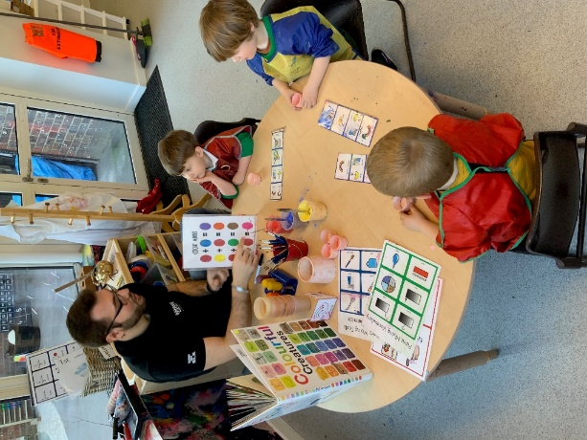
- Working closely with parents
- Modelling language in context
- Concrete, engaging learning activities
- Structured turn taking and collaborative play
- Repetition and continuation of learning activities
- Inclusive and enabling learning environment
- Use of visual supports to aid understanding

Interventions
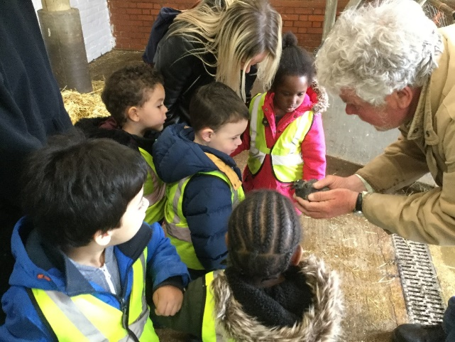
- Working closely with parents
- Modelling language in context
- Concrete, engaging learning activities
- Structured turn taking and collaborative play
- Repetition and continuation of learning activities
- Inclusive and enabling learning environment
- Use of visual supports to aid understanding

Impact
There are 9 children who are leaving us in July 2019 with SEND which includes 4 with an EHCP and 2 with applications for an EHCP.
Below is a breakdown of the progress of our children with SEND
On Entry |  |  |  |  | On Exit
 | % at age expected (secure 22-36 months) | % below expectations  (working towards 22-36 months) | Well below age related expectations | % at age expectations | % at age expected (secure 30-50 months) | Expected progress | Accelerated progress | Expected and accelerated progress
PSED | 0% | 0% | 100% | 0% | 22% | 11% | 89% | 100%
PD | 0% | 22% | 88% | 0% | 33% | 33% | 56% | 89%
CL | 0% | 0% | 100% | 0% | 11% | 11% | 89% | 100%
Case studies
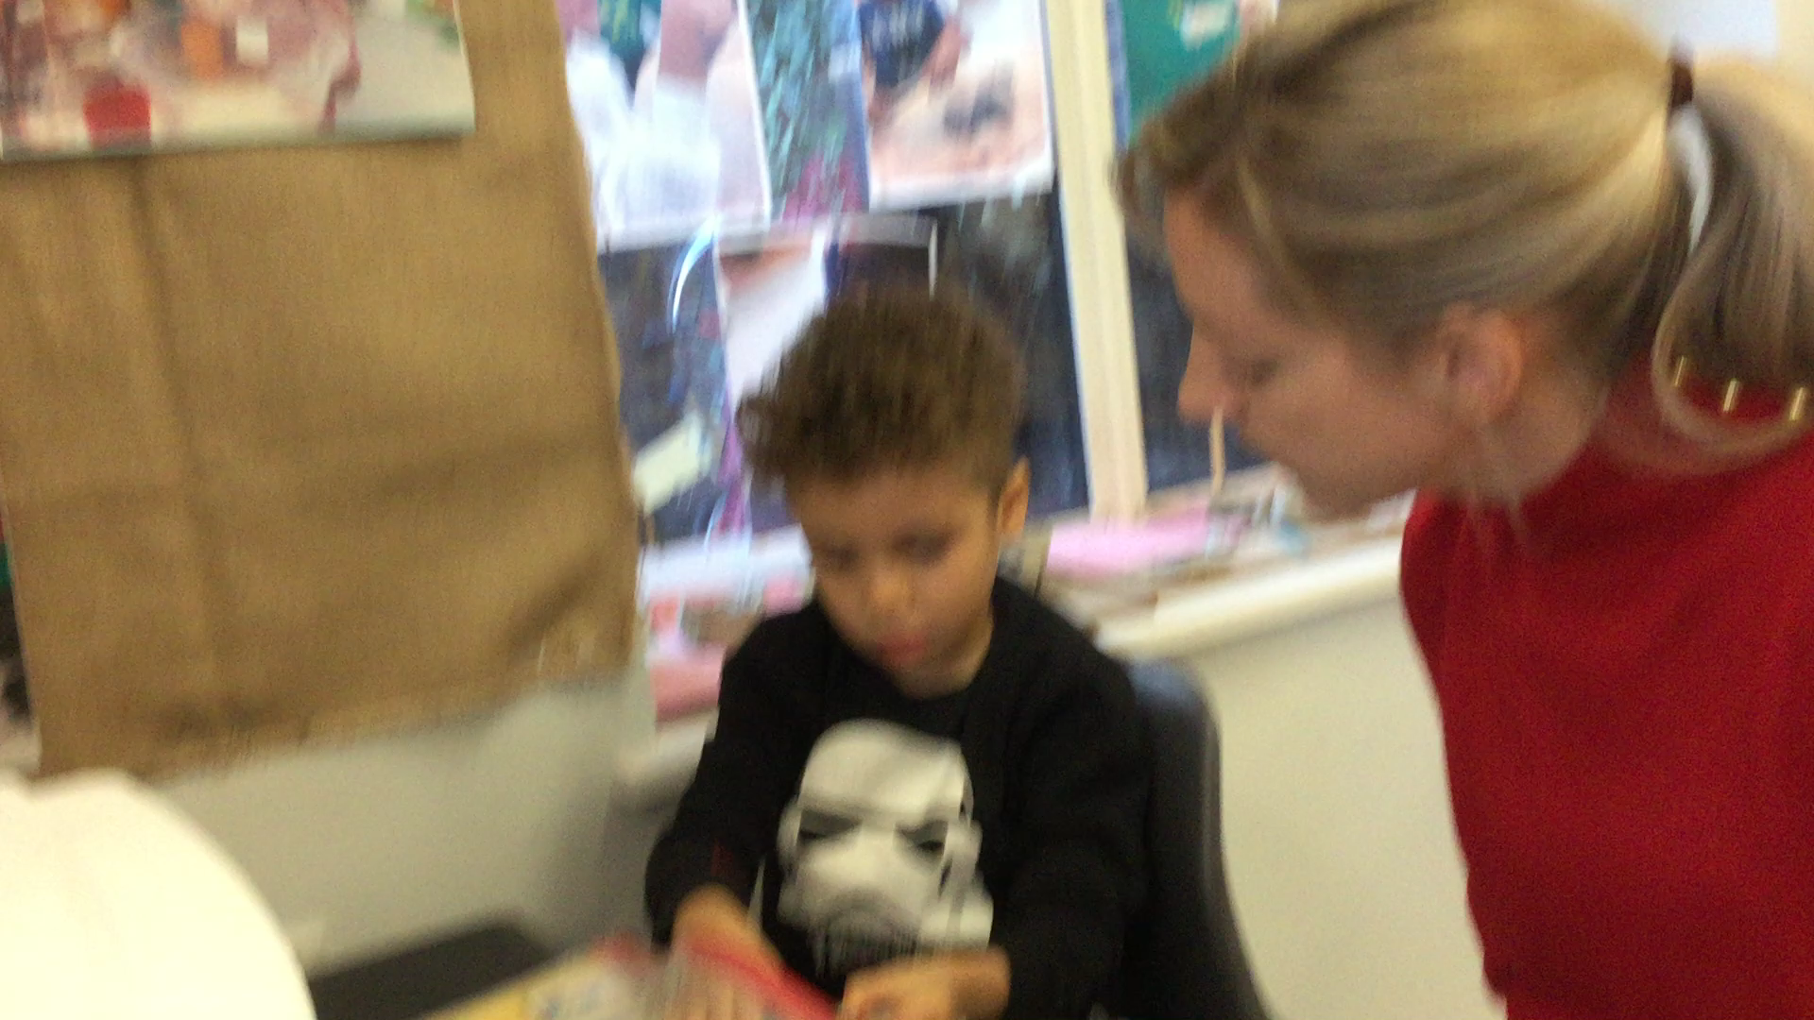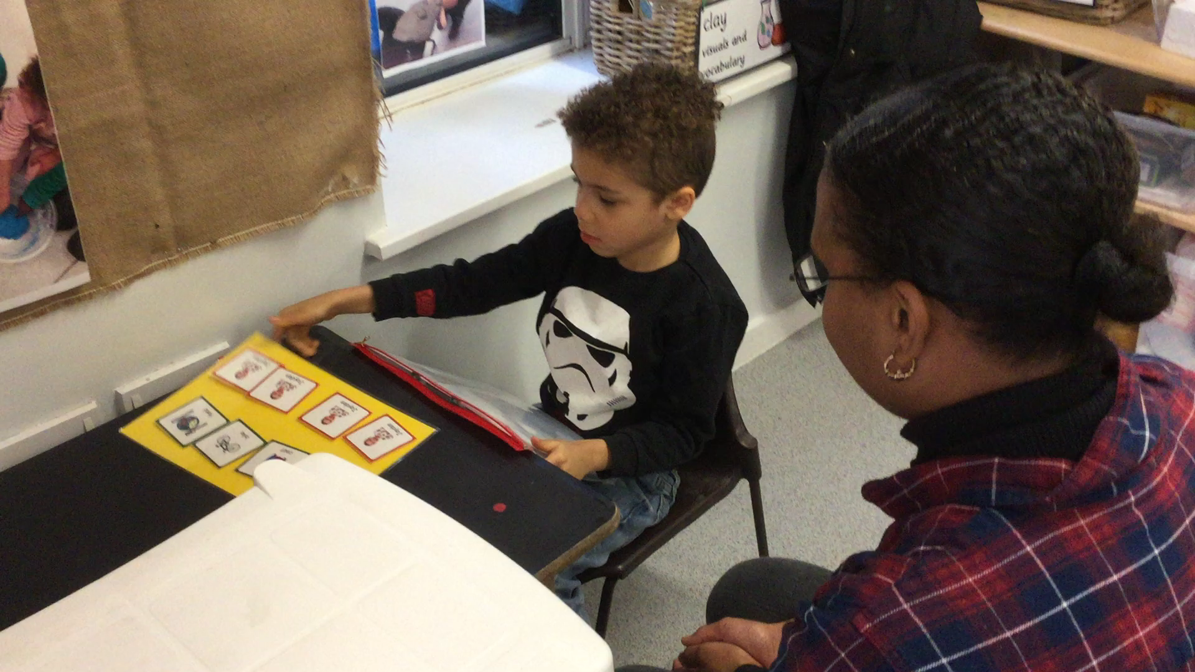
Interventions: PECS stages 1 – 4 in structured 1:1 sessions and out in the nursery, PECS at home with parent and sibling supported by SALT, Colourful Semantics during TEACCH approach, structured motivating groups.
Impact: xxx now distinguishes between adults and himself and will select the correct person’s photo to make a 2 symbol (subject-object) request and to comment on a photo, both at school and at home.

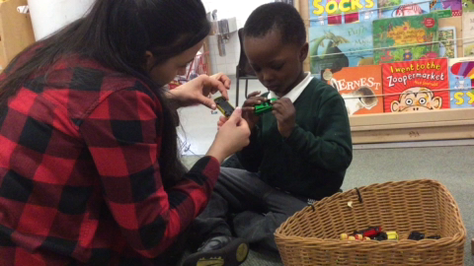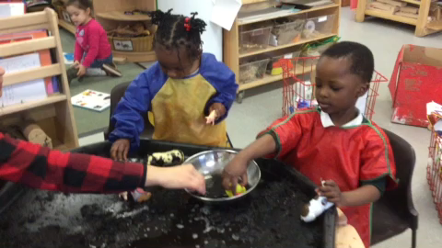

Interventions: Intensive Interaction, play partnering, following interests, modelling language in context, small group engaging activities.
Impact: xxx now shares an increased amount of joint attention with familiar adults, focuses his attention for longer periods during small groups (up to 15 minutes) and is naming objects and actions spontaneously!

