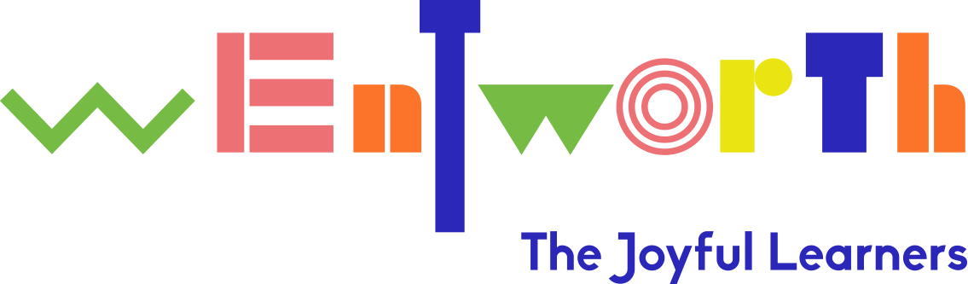

Wentworth Nursery School Eco Action Plan Summer Term 2021

Following the school’s Eco Audit the following points were identified by the children:

- More running opportunities

- More planting including planting of flowers

- To have a greater understanding about different countries including knowing how to say hello in different languages.

- To explore reducing pollution levels within our surround area including Cassland Road.
Lead staff member: Ben Hasan (Headteacher)

Objective | Current provision | Action | Outcome | Time | Evidence
To ensure there are more physical experiences including running within the school’s curriculum  Link to Healthy Living | There is continuous provision for challenging physical experiences including: climbing, balancing, climbing down a fire pole, climbing up a rope and balancing using gym rings.  The school through its curriculum delivery enables children to:  Balance, jump, climb, move in a variety of ways, participate in group games, developing skills in throwing and catching.  EYFS curriculum states the following: children at expected level of development will:  Negotiate space and obstacles safely with consideration for themselves and others:  Demonstrate strength, balance, co-ordination when playing.  Move energetically, such as running, jumping, dancing, hopping, skipping and climbing. | To plan more cardio vascular experiences  To plan learning experiences developing children’s understanding about what the heart is | To develop children’s understanding about the importance of exercises that make your heart beat quickly.  Children understand where their heart is.  Children know our heart needs to be beating all the time.  Children begin to understand the heart is a muscle | Summer Term 1  Summer 1 and 2 | HT blog  Weekly evaluations  HT report to Governors  School website
To ensure there are opportunities for children to develop their understanding about growing and planting  Link to Biodiversity | The school’s garden has opportunities for children to:  Harvest fruits and vegetables.  There is a gardener who works with the children covering a range of learning outcomes including:  - Understanding what plants need to grow,  - developing knowledge about composting  - attracting local wildlife by creating bird feeders. | To provide curricular learning experiences in:  Planting and growing. Including the growing of flowers and fruits | Children to know what plants need to grow.  Children know how to care for plants | Summer 1 and 2 | HT blog  Weekly evaluations  School website
To ensure children have a greater understanding about different countries, including how to say hello in different languages  Link to Global Citizenship | The school focuses on the following aspects:  Learning about cultures relating to children and staff within our community:  e.g Asian New Year  learning about Eid  Family walls talking about our families  The EYFS curriculum outlines the following:  - Describe their immediate environment using knowledge from observation, discussion, stories, non-fiction texts and maps;  - Know some similarities and differences between different religious and cultural communities in this country, drawing on their experiences and what has been read in class;  - - Explain some similarities and differences between life in this country and life in other countries, drawing on knowledge from stories, non-fiction texts and –when appropriate – maps. | As part of our work on cultures and community: children will be learning about saying hello in different languages incorporating working with parents. | Children are know how to say hello in at least three languages other than English.  To have an understanding of the UK and to know there are many countries in the world.  To know countries have similarities and differences. | Summer 2 | HT blog  Weekly evaluations  School website
To explore reducing pollution levels within our surround area including Cassland Road.  Link to Global Citizenship and litter | The school previously had liaised with Hackney Council and achieved the following:  Traffic speeds were monitored  Parent/children protests  Traffic light system extended  Traffic stopping distance extended | To establish the pollution impact of speeding vehicles. Subject to the above the school may:  contact councillors relating to pollution levels on Cassland Road  establish parent/child involvement in exploring ways of reducing pollution levels. | Clarity of key issues  Clarity on key actions the school and community can take to reduce pollution levels | Summer 2 | Eco Committee minutes  School newsletter

